# EXPRESS EDUCATION SERVICES LIMITED – 2024

# PRIMARY LEAVING SPECIAL MOCK

ENGLISH LANGUAGE

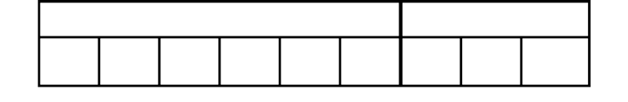***Time Allowed: 2 Hours 15 Minutes***

# Index No.

## Random No. Personal No.

**Candidate’s Name:**

**Candidate’s Signature:**

|  |  |  |  |
| --- | --- | --- | --- |
|  |  |  |  |

**DISTRICT ID NO.**

|  |  |  |
| --- | --- | --- |
| **FOR EXAMINERS ONLY** | | |
| **Qn. No.** | **MARKS** | **EXR’S NO** |
| 1 - 10 |  |  |
| 11 - 20 |  |  |
| 21 - 30 |  |  |
| 31- 40 |  |  |
| 41 - 43 |  |  |
| 44 - 46 |  |  |
| 47 - 49 |  |  |
| 50 - 52 |  |  |
| 53 - 55 |  |  |
| **TOTAL** |  |  |

2024 SPECIAL MOCK

Read the following instructions carefully

**Do not write your school or District name anywhere on this paper.**

1. This paper has two sections **A** and **B.**

Section A has 50 questions and Section B has 5 questions. This paper has **16** printed pages.

1. Answer **all** questions. **All** the working for both sections, A and B must be shown in the spaces provided.
2. **All** working must be done using a **blue** or **black**

ball-point pen or fountain pen. Any work done in pencil other than diagrams will not be marked.

1. No calculators are allowed in the examination room.
2. Unnecessary changes in your work may lead to loss of marks.
3. Any handwriting that cannot easily be read may

lead to loss of marks.

1. Do not fill anything in the table indicated: **“For Examiners’ Use Only”** and boxes inside the question paper

TURN OVER

**SECTION A: 50 Marks**

**SUB-SECTION I**

**In each of the questions 1-5, fill in the blank space with a suitable word.**

* 1. How .......................time will it take us to reach the market?
  2. Do you know the scientist who invented telephone?
  3. I would rather have a bath ...........................the evening than in the morning.
  4. The church ...................................was not available to play the piano at the function.
  5. .........................the cyclist seen the pothole, the accident would not have happened.

## For questions 6-15, use the correct form of the words given in brackets to complete the sentences.

* 1. Our team lost the match because they did not prepare themselves. (good)

**7.** The rich man is............................................the road to the church voluntarily. (wide)

1. I wrote to Jessica but she has not ......................to my letter.(reply)
2. Juliana’s voice is much .......................than Irene’s. (soft)
3. When you feel.................................,you can eat one of the apples in the fridge.(hunger)
4. My old mother ..................................me on her back every day when I was a little child.(carry)

Turn over

**12.** The customer does not like .................................designs. (circle)

1. After a hot argument with the traffic officer, the stubborn

..........................drove off fast.(motor)

1. This drug will make you feel some .............................,but you will be fine in a few minutes.(comfort)
2. The French ...........................rejected the accommodation the hotel management had arranged for him.(tour)

## In questions 16 and 17, use each of the words in a sentence to show that you know the difference in their meaning.

1. march

....................................................................................................................................

..................

..................................................................................................................................

1. match

...................................................................................................................................

...................................................................................................................................

## In questions 18 – 20, re-write the sentences using the opposite of the underlined word.

1. The pedestrian turned left when he reached the junction.

...................................................................................................................................

1. The food was too hot for me to eat.

...................................................................................................................................

1. My sister does not like tight clothes.

...................................................................................................................................

Turn over

## Write the following abbreviations in full.

1. esp.

..................................................................................................................................

1. ATM

..................................................................................................................................

## In questions 23 and 24, re-write the sentences using a single word in the place of the underlined words.

1. The waitress forgot to give me forks, spoons and knives.

...................................................................................................................................

...................................................................................................................................

1. My mother and my father have gone to Dubai on a business trip.

...................................................................................................................................

...................................................................................................................................

## Write the plural form of the given words.

1. Workshop

.................................................................................................................................

1. potato

.................................................................................................................................

## Arrange the given words in alphabetical order.

1. mercy, kindness, politeness, happiness

.....................................................................................................................................

1. deer,dove,buck,doe.

.....................................................................................................................................

## In questions 29 and 30, re-arrange the words to form meaningful sentences.

1. sick lunch not has The had boy.

....................................................................................................................................

1. noise Did hear you that?

....................................................................................................................................

Turn over

## SUB-SECTION II

**In questions 31 to 50, re-write as instructed in brackets.**

1. Betty will be given permission to go home. Cathy will be given permission to go home.(Join beginning: Both )

...................................................................................................................................

...................................................................................................................................

1. Kagolo did all the chores alone. (Rewrite ending. himself)

...................................................................................................................................

...................................................................................................................................

1. I didn’t watch my favourite show because the power supply failed. (Rewrite using .........................would have watched )

...................................................................................................................................

...................................................................................................................................

1. Immediately Kabulete joined the team, he scored a goal.(Rewrite beginning: No sooner )

...................................................................................................................................

...................................................................................................................................

1. Marion did not write a letter. Paul did not write a letter. (Join using.........................and neither. )

...................................................................................................................................

1. The proposers debated very well but they did not win the debate. (Rewrite beginning: Although )

...................................................................................................................................

...................................................................................................................................

37.I need more time to complete the work. (Rewrite using request

..............)

...................................................................................................................................

...................................................................................................................................

* 1. Allen turned off the radio. She wanted to read a book . (Join using:.................so that )

...................................................................................................................................

...................................................................................................................................

Turn over

* 1. The government decided to build a new hospital. This pleased the residents. (Join beginning: The government’s )

...................................................................................................................................

...................................................................................................................................

* 1. There is an entrance on both sides of the fence.(Rewrite using:..........either. )

...................................................................................................................................

...................................................................................................................................

* 1. It is not necessary for you to buy a new book. (Rewrite using .......................... needn’t )

...................................................................................................................................

...................................................................................................................................

* 1. Unless you come early, you will not find me home. (Rewrite using ..........or else

........)

...................................................................................................................................

...................................................................................................................................

* 1. “Iam washing the dishes,” said Mary. (Rewrite using ..............said that

...............)

...................................................................................................................................

...................................................................................................................................

* 1. The carpenter made a stool with three legs. (Rewrite using a

three. )

...................................................................................................................................

* 1. How long is your rope? (Begin: What )

.....................................................................................................................

* 1. The man kept asking me questions. I sat with him on the plane. (Join using...................whom. )

...................................................................................................................................

...................................................................................................................................

Turn over

* 1. There are very few Ugandan guests at the party .(Rewrite using:............hardly )

...................................................................................................................................

...................................................................................................................................

* 1. Jonah asked the teacher how long he would take marking the exercise. (Rewrite ending .................................................asked Jonah.)

...................................................................................................................................

...................................................................................................................................

* 1. Prisca borrowed a tablet from Haula. (Rewrite using.............................lent )

...................................................................................................................................

...................................................................................................................................

* 1. My grandfather is very weak. He cannot go to church by himself. (Join using ....................too...........to )

...................................................................................................................................

...................................................................................................................................

Turn over

## SECTION B: 50 MARKS

Questions **51** to **55** carry ten marks each.

## Read the passage and answer the questions about it in full sentences.

On 22nd September, 2024, my class held a leavers’ party to bid farewell to the candidates who will sit for the Primary Leaving Examination at the beginning of November. The party was initially planned to take place at school but the candidates requested the head teacher to organise it on the beach. They said that the beach is more interesting than school, adding that they would like to have as much fun as possible. The head teacher granted their request despite the additional cost it would result in for example transport and hiring the venue. He told each of the candidates to contribute Sh 80,000.

The candidates requested permission to go home to collect their best clothes for the party .They wanted to look smart while others wanted to carry their swimming costumes with them. On reaching Sand Beach Nabugabo, the candidates were received by ushers from Ebenezer Events Limited, the company that was given the **task** of organising the party. The seats and tables were decorated very nicely. The decorators had used colours involving royal blue, orange and white. These are the same colours for our school uniforms.

After the candidates had taken their seats, the MC asked them to go to the DJ’s desk and submit their track requests. They quickly did that and after a short while the Dj played the tracks one after the other as we danced to the music. Some pupils, however, were shy and chose to remain in their seats instead of dancing. A dance competition was held and my friend, Tricia, won. She was given Shs 500,000 as a prize.

At around midday, the event organisers started serving the guest with a very **delicious** meal that comprised various courses. The main course was rice and roasted chicken. As soon as everyone had finished their meal, the MC announced that we were free to engage in various activities depending on our interests.

Some candidates took boat rides whereas others went to swim in the lake. Most of the boys remained dancing, but they later went to play beach soccer.

If it had not got too dark, I don’t think the party would have ended. We were driven back to the school in a joyous mood because we had had a fun-filled day. **QUESTIONS**

1. What took place on 22nd September, 2024?

...................................................................................................................................

1. Why did the writer’s class hold a party?

...................................................................................................................................

1. On which beach was the party organised?

...................................................................................................................................

1. Why did the pupils prefer to have the party away from school?

...................................................................................................................................

1. How much money did each candidate pay?

...................................................................................................................................

1. Why do you think Tricia was happy at the end of the dance competition?

...................................................................................................................................

1. Why did some pupils choose to remain in their seats instead of dancing?

...................................................................................................................................

1. Give another word or group of words with the same meaning as the underlined words in the passage.

i) task.....................................................

ii) delicious..............................................

j) Suggest a suitable title for the story.

...................................................................................................................................

Turn over

## The sentences below are in the wrong order. Read them carefully and rearrange them to form a sensible story.

1. The milk is collected in big cans and then measured.
2. Mr Mukasa is a very prominent farmer in Kagando Village.
3. The government was recently happy with his work and promised to give him tractors and machines.
4. It is then transported to the dairy in town where it is sold.
5. He has also been able to buy more land to widen his farm.
6. He practices both livestock and crop farming.
7. Measuring the milk helps Mr Mukasa to know how many litres of milk his farm produces.
8. There are dairy cattle on the livestock farm and coffee, bananas and maize on the crop farm.
9. From the milk sales, Mr Mukasa gets money to pay his workers and his children’s school fees.
10. He has workers who are responsible for grazing the cattle and milking them.

...................................................................................................................................

...................................................................................................................................

...................................................................................................................................

...................................................................................................................................

...................................................................................................................................

...................................................................................................................................

...................................................................................................................................

...................................................................................................................................

...................................................................................................................................

.....................................................................................................................................

.................

.................

.....................................................................................................................................

.....................................................................................................................................

Turn over

## Below is a cover page of an examination paper. Study it carefully and answer questions about it in full sentences.

**STEP HIGHER JUNIOR SCHOOL WEEKEND EXAMINATION SET 2** ENGLISH FOR P.7

## NAME: AGUTI MERCY

**Index No.**

|  |  |  |  |  |  |  |  |  |
| --- | --- | --- | --- | --- | --- | --- | --- | --- |
| **2** | **2** | **3** | **2** | **1** | **6** | **0** | **0** | **1** |

## SIGNATURE: Aguti Mercy.

**SCHOOL CODE**

## DO NOT OPEN THIS BOOKLET UNTIL YOU ARE TOLD TO DO SO

**Read the following instructions carefully.**

|  |  |  |
| --- | --- | --- |
| **FOR EXAMINER’S USE ONLY** | | |
| **QN. NO.** | **MARK** | **SIGNATURE** |
| **1-10** |  |  |
| **11 - 20** |  |  |
| **21 – 30** |  |  |
| **31 – 40** |  |  |
| **41 – 50** |  |  |
| **51** |  |  |
| **52** |  |  |
| **53** |  |  |
| **54** |  |  |
| **55** |  |  |
| **TOTAL** |  |  |

1. This paper has **two** Sections: **A** and

**B**.

Section **A** has 50 questions and Section B has 5

1. Answer **ALL** questions.
2. Use only blue ink.
3. Only diagrams and graphs may be drawn in pencil.
4. Unnecessary changes of work will lead to loss of marks.
5. Poor handwriting will lead to loss of marks.
6. Do not fill anything in the boxes indicated “for examiner’s use only” and those inside the question paper.

Turn over

## QUESTIONS

1. For which school is the above examination?

...................................................................................................................................

1. Which class sat for the examination?

...................................................................................................................................

1. Who is the first pupil on the alphabetical list of the primary seven class?

...................................................................................................................................

1. How many sections are in the paper?

...................................................................................................................................

1. When did the class sit for the examination?

...................................................................................................................................

1. What will happen to a candidate who will not answer all questions?

...................................................................................................................................

1. When is a candidate allowed to use a pencil?

...................................................................................................................................

1. How many boxes are provided for filling in the index number?

...................................................................................................................................

1. Why do you think the candidate did not fill in the space for school code?

...................................................................................................................................

1. What colour of ink are the candidates allowed to use?

...................................................................................................................................

Turn over

## Read the notice below carefully and then answer the questions about it in full sentences

**PUBLIC NOTICE**

BANK OF UGANDA WARNS THE GENERAL PUBLIC AGAINST **SEEKING** FINANCIAL SERVICES FROM UNLICENSED FINANCIAL INSTITUTIONS CURRENTLY OPERATING **ILLEGALLY**. YOU ARE FURTHER ADVISED TO REPORT SUCH INSTITUTIONS TO BOU BY CALLING THE TOLL FREE HOTLINE 00800923848 OR GO TO THE NEAREST POLICE STATION. THE LICENSED BANKS INCLUDE AMONG OTHERS CENTENARY BANK, STANBIC BANK, TROPICAL BANK AND CAIRO BANK

ANGUZU PETER SECRETARY FOR PUBLIC AFFAIRS

BANK OF UGANDA 2ND OCTOBER, 2024

**Questions**

* + 1. What do we call the above information?

...................................................................................................................................

* + 1. What is Bank of Uganda warning the public against?

...................................................................................................................................

* + 1. Why do you think the managers of unlicensed financial institutions will be arrested?

...................................................................................................................................

* + 1. How much money will a caller pay to call the given telephone number?

...................................................................................................................................

* + 1. Why do you think it is not good to allow unlicensed financial institutions to operate?

...................................................................................................................................

Turn over

* + 1. How many institutions have been mentioned as licensed institutions in the notice?

...................................................................................................................................

* + 1. Who wrote the notice?

...................................................................................................................................

* + 1. Give another word or group of words with same meaning as the underlined words in the notice

i) seeking ..............................................

j) ii) illegally.....................................................

k) When was the notice written?

...................................................................................................................................

Turn over

## The pictures A – F tell a story. Study them carefully and write a sentence to describe what is happening in each picture. You will also answer the additional questions. You may use the following words to help you restaurant welcome serve children customers

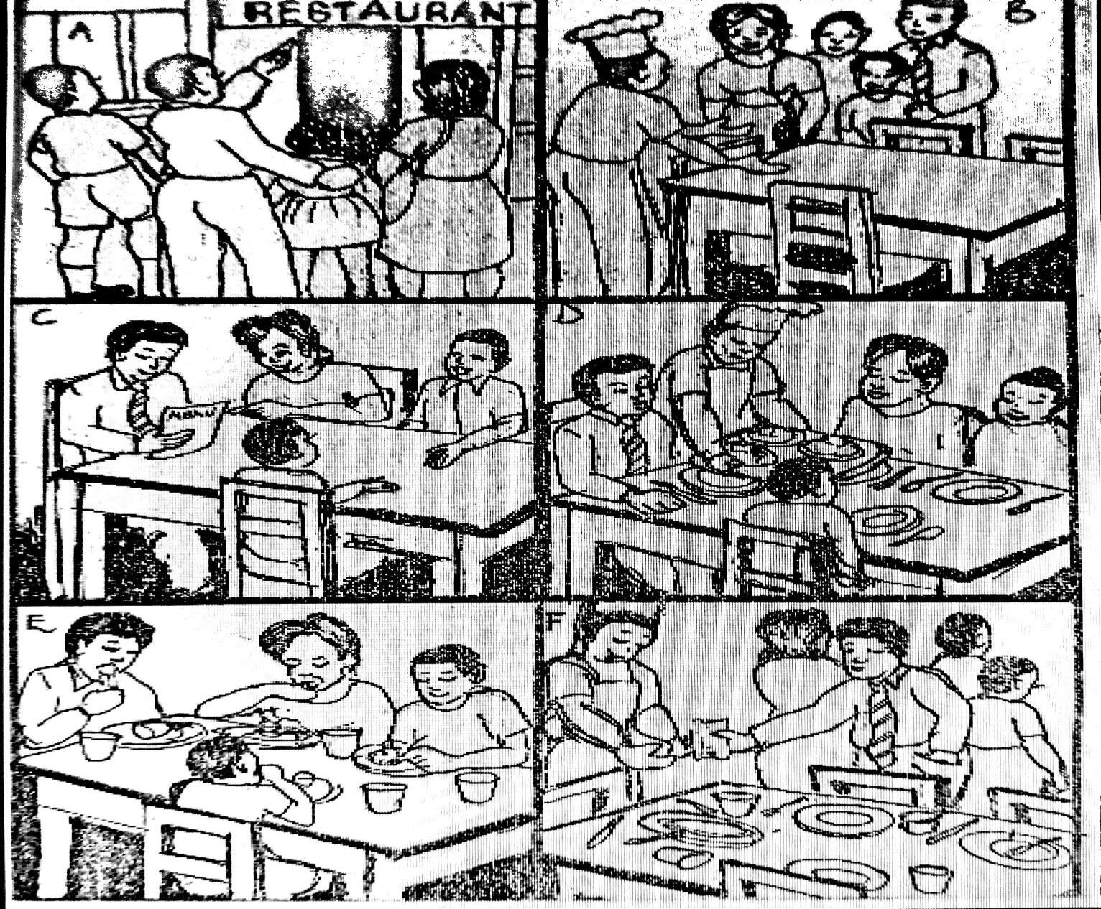study order family cashier pay waiter eat parents bill food

Turn over

a) Picture A .............................................................................................................

.....................................................................................................................................

b) Picture B .............................................................................................................

.....................................................................................................................................

c) Picture C ..............................................................................................................

.....................................................................................................................................

d) Picture D ............................................................................................................

.......................................................................................................................

e) Picture E

............................................................................................................

2024 SPECIAL MOCK

.....................................................................................................................................

f) Picture F ..............................................................................................................

.....................................................................................................................................

1. Why are the customers studying the menu in Picture C?

.....................................................................................................................................

1. How many people ordered some food at the restaurant?

.....................................................................................................................................

1. Mention one tool the customers used when they were eating food?

.....................................................................................................................................

1. Why do you think the family decided to have a meal at the restaurant?

.....................................................................................................................................

# END